**Data Science Project Report**

Diabetes Prediction Model

Submitted by: Radhika

([21bce055@nith.ac.in](mailto:21bce055@nith.ac.in))

**Table of Contents**

1. Introduction
2. Existing Method
3. Significance of Data Analysis
4. Methodology of data analysis

4.1. Data Collection

4.2. Data Preparation

4.3. Exploratory Data Analysis

4.4. Data Standardization

4.5. Data splitting

4.6. Model evaluation

4.7. Making a predictive system

1. References
2. Introduction

**Diabetes** is a chronic medical condition characterized by high levels of glucose (sugar) in the blood. It occurs when the body either cannot produce enough insulin (a hormone produced by the pancreas) or cannot effectively use the insulin it produces.The effects of diabetes are wide-ranging and can lead to serious health complications if not properly managed. Chronic high blood sugar levels can damage blood vessels and nerves, leading to cardiovascular diseases such as heart attack and stroke, and complications in the eyes (retinopathy), kidneys (nephropathy), and peripheral nerves (neuropathy). This can result in vision impairment, kidney failure, and loss of sensation or pain in the extremities, potentially leading to amputations. Additionally, diabetes can cause slow wound healing, increase susceptibility to infections, and significantly impact quality of life. Effective management through lifestyle changes, medication, and regular monitoring is crucial to mitigate these adverse effects and maintain overall health.

Diabetes Prediction is important for:

1. Early Detection: Predicting diabetes can help in identifying individuals at high risk before the onset of the disease, allowing for early intervention.
2. Preventive Measures: Early prediction enables lifestyle changes, such as diet and exercise modifications, which can prevent or delay the onset of Type 2 diabetes.
3. Improved Management: For those already diagnosed, predicting complications can lead to better management and treatment plans, reducing the risk of severe outcomes like cardiovascular diseases, neuropathy, and kidney failure.
4. Healthcare Cost Reduction: Early prediction and intervention can significantly reduce healthcare costs by preventing severe complications and hospitalizations.
5. Enhanced Quality of Life: Timely prediction and management can improve the overall quality of life for individuals by maintaining better health and preventing the adverse effects of diabetes.

2. Existing Methods

Before the advent of modern data analysis, diabetes prediction primarily relied on traditional clinical methods and diagnostic tests. These methods included comprehensive patient history assessments, where doctors gathered detailed information about a patient's family history, lifestyle, and symptoms such as frequent urination, excessive thirst, and unexplained weight loss. Physical examinations were conducted to identify signs of diabetes, like obesity, high blood pressure, and specific skin conditions. Diagnostic tests played a crucial role, with the fasting blood glucose test measuring blood sugar levels after an overnight fast, the oral glucose tolerance test evaluating the body's response to a sugary drink, and the glycated hemoglobin (A1C) test providing an average blood glucose level over two to three months. Additionally, urine tests for glucose or ketones and blood tests for insulin and C-peptide levels helped in diagnosing and distinguishing between types of diabetes. Risk assessment tools, such as questionnaires and risk scores, were also used to evaluate the likelihood of developing diabetes based on factors like age, BMI, and family history. These conventional methods, while effective to a certain extent, often relied on observable symptoms and well-known risk factors, potentially delaying the early detection and intervention that modern data analysis techniques can now provide

3. Significance of Data Analysis

Data analysis in diabetes prediction is crucial for early detection and management of the disease, allowing healthcare providers to identify high-risk individuals before symptoms manifest. This facilitates timely interventions, such as lifestyle changes and personalized treatment plans, which can prevent or delay the onset of diabetes and its complications. Effective data analysis also optimizes healthcare resources by focusing efforts on prevention and early intervention, reducing overall costs. Furthermore, it enhances patient outcomes by minimizing the risk of severe complications like cardiovascular disease, neuropathy, and kidney failure. In public health, data-driven insights help design targeted preventive strategies and inform policy-making to address the root causes of diabetes. Continuous monitoring and evaluation of diabetes trends through data analysis enable the refinement of healthcare strategies, ultimately leading to improved patient care and better health outcomes.

4. Methodology of diabetes prediction using Machine Learning and Python are:

### **4.1. Data Collection:** Collect relevant data, such as the Pima Indians Diabetes Dataset, which includes features like age, BMI, glucose levels, blood pressure, insulin levels, etc.

**4.2. Data Preparation**

4.2.1. Importing libraries

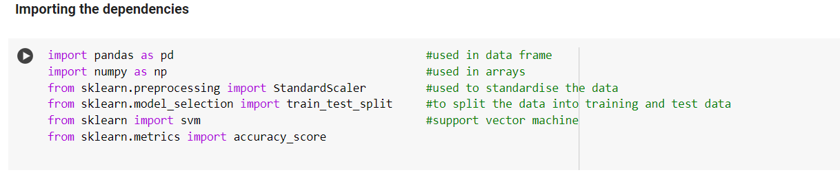

4.2.2. Importing dataset

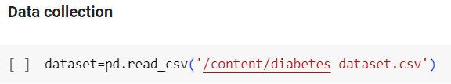

**4.3. Exploratory Data Analysis:** It is a crucial phase in the data science process where analysts use statistical and graphical techniques to understand the characteristics of the data. EDA helps in uncovering patterns, spotting anomalies, testing hypotheses, and checking assumptions through visual and quantitative methods.

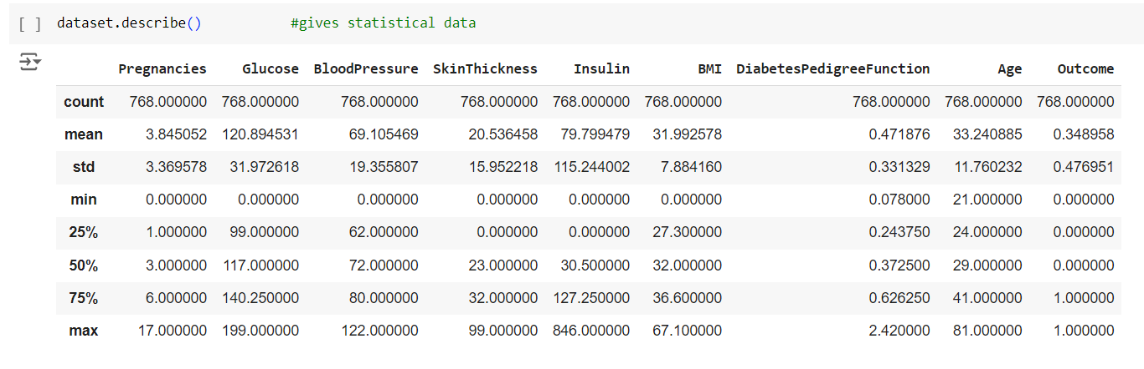

### **4.4. Data Standardization:** Data standardization is a crucial preprocessing step in data analysis and machine learning, as it transforms features to have a mean of zero and a standard deviation of one. This process ensures that each feature contributes equally to the analysis, which is vital for the performance and reliability of many algorithms, such as logistic regression and support vector machines, that are sensitive to the scale of input features. Standardization prevents features with larger ranges from dominating the learning process, leading to more balanced and interpretable results. It also facilitates faster and more reliable convergence in optimization algorithms like gradient descent, enhances the interpretability of linear model coefficients.

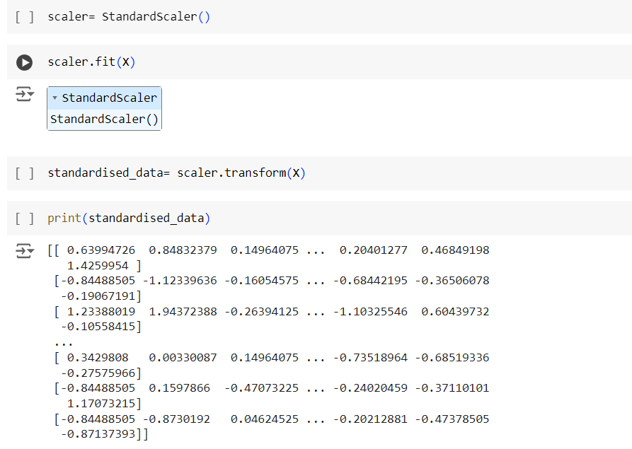

**4.5. Data splitting**: Data splitting is a foundational practice in machine learning, essential for ensuring the reliability and generalizability of models. By dividing a dataset into distinct subsets—typically training and testing sets—data splitting enables rigorous evaluation of a model's performance on unseen data. The training set is used to train the model on patterns in the data, while the testing set serves as a proxy for real-world scenarios, assessing how well the model generalizes to new observations. This process is crucial for detecting and mitigating overfitting, where a model learns specific details from the training data that do not apply to unseen data. Data splitting plays a pivotal role in estimating a model’s generalization error and selecting the most effective model for deployment, thereby enhancing the reliability and performance of machine learning applications across various domains.

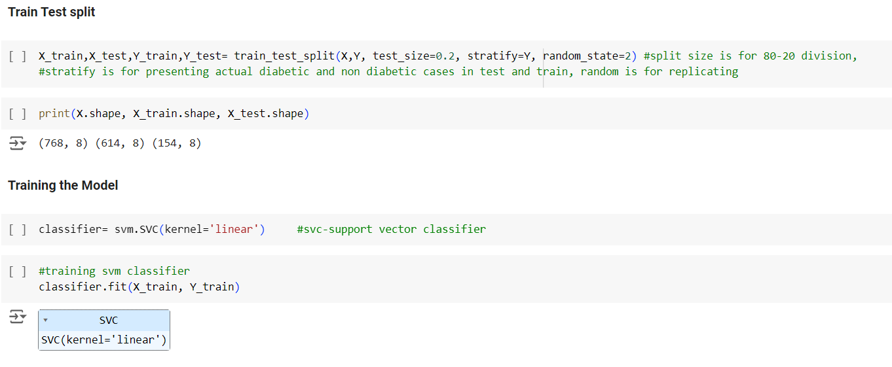

**4.6. Model evaluation:** Model evaluation is a critical aspect of machine learning that determines the effectiveness and reliability of predictive models. It involves assessing how well a trained model performs on unseen data, which is crucial for making informed decisions and deploying models in real-world applications.

Model evaluation provides insights into how accurately the model predicts outcomes on new data. By testing the model on a separate testing set that was not used during training, we can measure metrics such as accuracy, precision, recall etc.

Model evaluation helps in identifying and mitigating issues such as overfitting and underfitting. Overfitting occurs when a model learns noise and specifics of the training data too well, resulting in poor performance on unseen data. Conversely, underfitting indicates that the model is too simplistic to capture the underlying patterns in the data.

Model evaluation supports the iterative improvement of machine learning models. By analyzing the results from model evaluation, data scientists can iteratively refine feature engineering and other aspects of the modeling process to achieve better performance. This iterative approach helps in continuously enhancing the model's predictive power and ensuring its relevance and reliability over time.

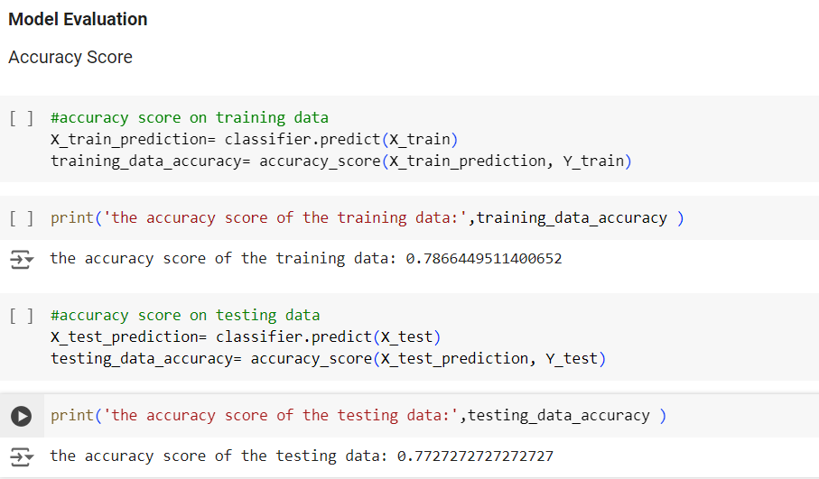

**4.7. Making a predictive system:**.

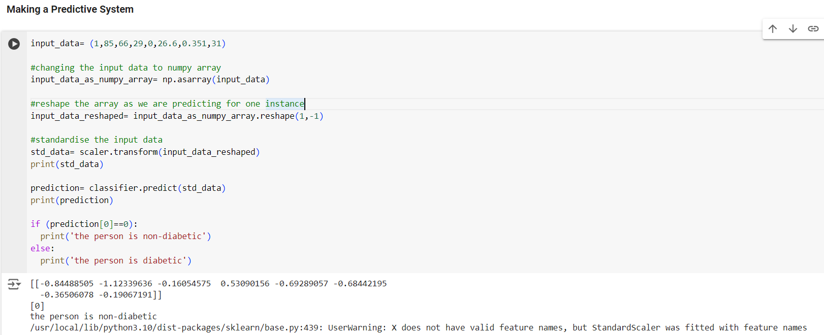

This code was used to make a prediction about whether a person is diabetic or non-diabetic based on their health metrics, using a machine learning model

In the code provided in the picture input data is provided which is a tuple and this tuple contains the values of various health-related features for a single individual: Pregnancies, Glucose, BloodPressure, SkinThickness, Insulin, BMI, DiabetesPedigreeFunction, and Age. These features are the inputs to the machine learning model, which uses them to predict the likelihood of diabetes.

Then the input data is converted from a tuple to a NumPy array.this is because many machine learning libraries, including scikit-learn, require input data to be in NumPy array format for compatibility with their functions and methods.

Reshaping of the array is done to ensure it has one row and the appropriate number of columns. This is done because the model expects the input to be in a 2D array format, even if predicting for a single instance. Reshaping ensures that the array has the correct dimensions for processing.

Then the standardization transformation is applied to the input data. As discussed earlier, the model was likely trained on standardized data (mean=0, standard deviation=1). Standardizing the input data ensures that it is on the same scale as the training data, improving the model’s performance and reliability.

At last the trained classifier is used to make a prediction based on the standardized input data.As the classifier has learned patterns and relationships in the data during training, and it uses this knowledge to predict whether the individual is diabetic or non-diabetic based on their features. The prediction output from the classifier is typically a numerical label (e.g., 0 for non-diabetic, 1 for diabetic).

5. References

1. National Institute of Diabetes and Digestive and Kidney Diseases. (2019). Pima Indians Diabetes Dataset.
2. Sinha, M. R. (2018). Application of Machine Learning for Predicting Diabetes Mellitus. [Thesis]. Indian Institute of Technology Bombay.
3. Priya, R. (2018). Prediction of Diabetes Using Machine Learning Algorithms. [Thesis]. Indian Institute of Technology Madras.